Advanced Games Programming
Tutorial 09 - Lighting

Introduction

In the real world the apparent colour of an object as it appears to your eye is not necessarily the same as its actual colour. External sources of light play a part too. For instance, a pure white cube positioned below a strong red light will appear red. Likewise, at night, the colour of objects is not apparent. For instance if you're out walking in the countryside at night the trees, the grass, and everything else will appear grey, due to the near-absence of light. So, to develop a realistic game, you need to take both sources of light and object colours or textures into account, and this is done by creating lights.

Lighting in Computer Graphics

The light that you see in the real world is an extraordinarily complex system of different types of light, many light sources, multiple reflections and refractions, different levels of absorption and translucence, etc. To model all this in real time would be impractical, so in games much simpler models are used that can be calculated very quickly.

There are three basic types of light that are used when generating computer graphic images:

Ambient light: light which doesn't come from a particular source or direction, and lights objects evenly. A good example would be the light you get indoors from the sun even if it doesn't directly illuminate the inside. In the real world this generally comes from the multiple re-reflections of light off many surfaces. Below is a picture of four cubes being displayed using a grey ambient light only. Notice that the lighting is completely uniform, ambient light lights every surface in the scene evenly, no matter it's orientation or position:

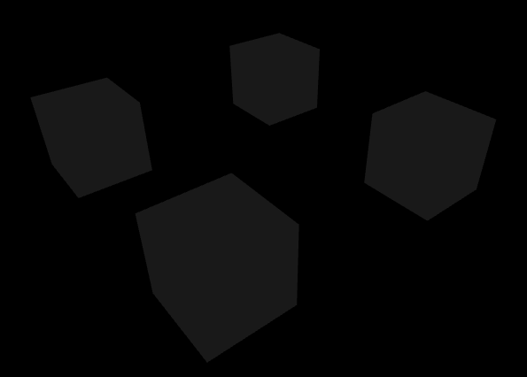

Diffuse light: light which comes from a particular source, from a particular direction, but which illuminates a surface evenly. A fluorescent tube light, or the sun shining on the ground, is a good example. The cube below is lit using just grey diffuse light:

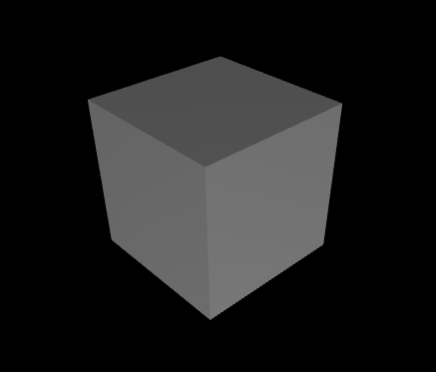

Specular light: light which comes from the direct reflection of a light source, and generally illuminates a small area on a surface particularly strongly. The bright highlights you see when shining a light on a metallic surface would be a good example. Below is a red sphere showing a specular highlight from a yellow light:

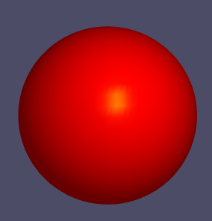

Every light source produces a mixture of these three light components in differing proportions, rather than just one. For example the sun might produce:

- ambient light in the form of light scattered off many surfaces;
- diffuse light in the form of the sun shining on a non-reflective surface (e.g. grass, a road);
- and specular light in the form of reflections off a shiny surface such as a window or a car.

Material Properties, Textures and Reflectance

Lights are not the only things that determine the final colours you see in a scene. You have already seen that textures can be used to give objects the appearance of different surfaces, but in addition you can also set the material properties of the objects faces in the scene. The material properties describe the reflectance of a face, which is how much of each primary colour of light (red, green and blue) that the surface reflects. Another way to visualise this is the material properties describe the actual colour of the face if it were viewed when lit by a pure white light.

Understanding Colour

Why do objects appear to be a certain colour? To understand this you need to understand why objects are coloured. A blue ball, for example, is blue because it absorbs red and green light. If you place the ball under a white light, as white light is a mixture of red, green and blue light the result will be that the ball will reflect only blue light. This is because it will have absorbed the red and green components of the white light striking it.

Thus in general, in the real world, objects are the colour that they are because they absorb certain colours and emit the remainder. The colour of an object is a mixture of the colours that the object emits.

To take another example: A yellow ball is yellow because it absorbs blue light. It therefore emits red and green light. A mixture of the emitted light - red and green - gives yellow.

Types of Light

There are three basic types of light used in computer graphics, directional, point and spotlight. Each of these produces a different sort of effect that approximate different types of lights that you find in the real world:

Directional Lights: This type of light models the kind of lighting that broadly lights a scene from one direction. This is similar to light coming from the sun, it is so far away and large that light rays coming from it are essentially parallel so everything is lit the same from that direction. When rendering it causes all faces in a scene to be lit equally from the same direction, in the following image you can see the sides of each cube are lit the same, regardless of position:

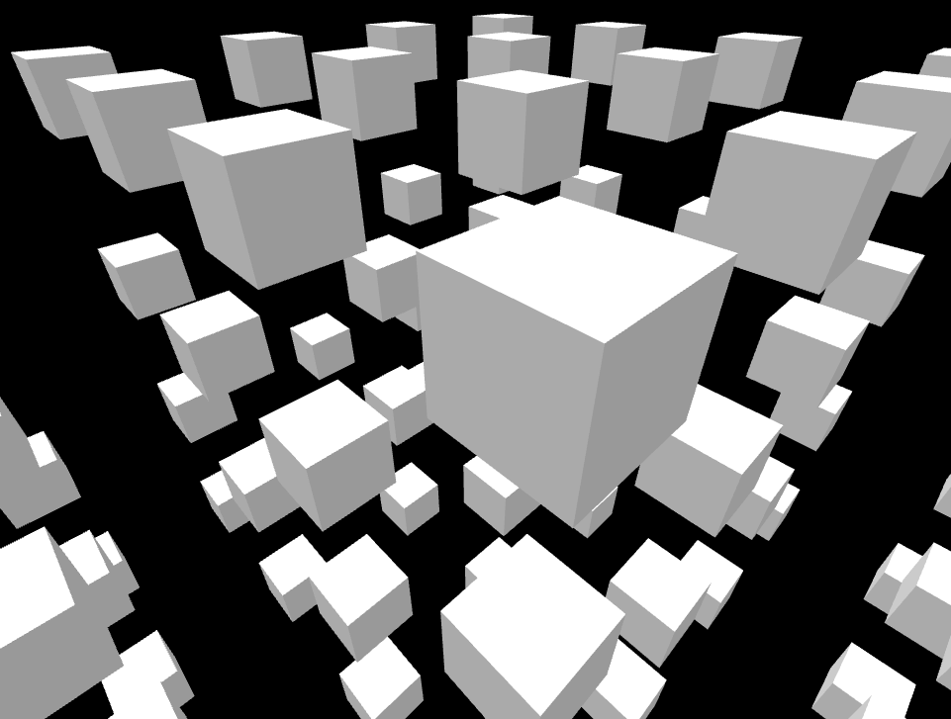

Point Lights: This type of light represents a light that originates from a point in space, similar to the way a light bulb works. Faces are lit depending on their relationship to the position of the light, and the distance. The light tends to lose intensity with distance, and this is called light attenuation. The following picture shows a point light lighting a scene, notice how the intensity fades with distance, and also that the faces away from the light can still be seen, as ambient light has also been included:

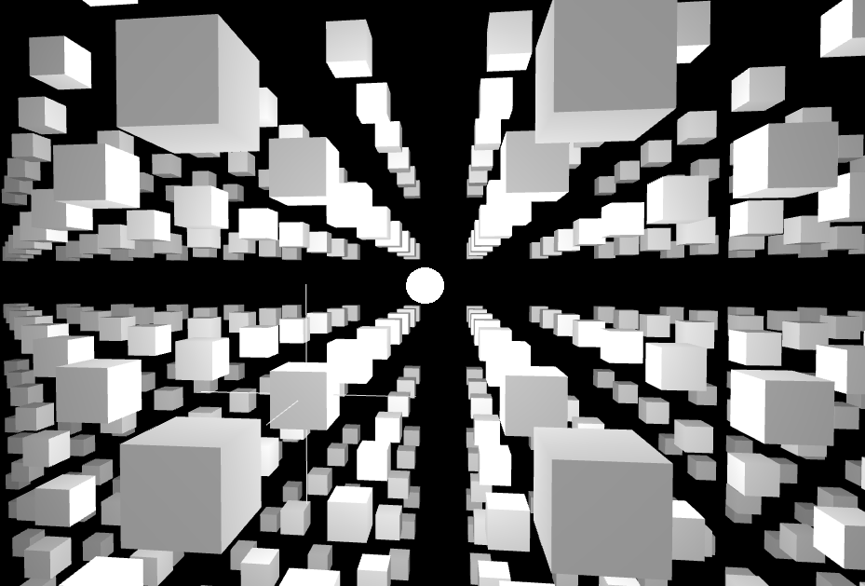

Spot Lights: This type of light represents a light with a particular position and direction, and just like a spot light or a torch it illuminates objects within a cone of light in the specified direction:

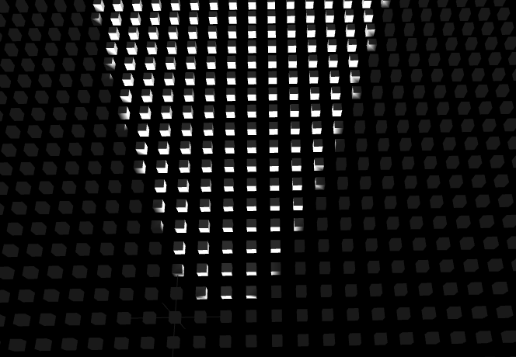

Normals

In order to light a model you need to determine the orientation of each face of the model with respect to a light. This is done using normals. These are unit vectors that that are perpendicular to the plane of any given face of a model, here are three face normals for a cube:
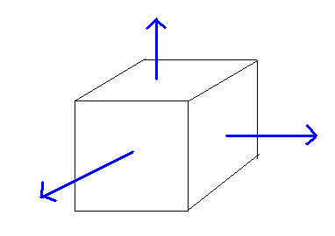

Normals are used to determine how much light a face receives from a light source - the bigger the angle away from the light the less the face is lit:
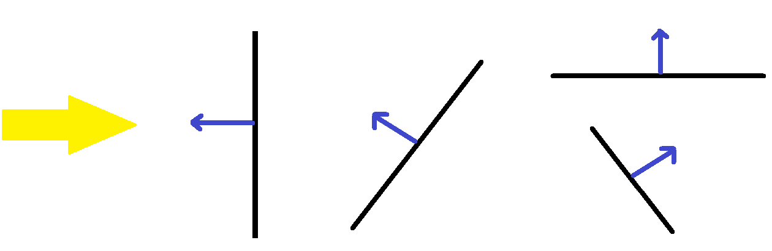LIGHT DIRECTION FULLY LIT HALF LIT UNLIT

Because there is no concept of a face normal in Direct3D, normals are stored in every vertex for each triangle representing a face, and interpolated across the face of the triangle as with other vertex elements.

Lighting Using a Directional Light

In order to calculate the amount of light a face receives from a directional light you need two vectors, the normal and a vector that points towards the source of the light. If both of these vectors are of unit length then a simple dot product can determine the amount of light. If two unit vectors are parallel (i.e. 0 degrees difference in direction) then a dot product returns the value 1.0, which means fully lit. If two unit vectors are perpendicular (90 degrees difference in direction) then the value is 0.0, which means not lit. The range of value in between ensures a smooth transition from lit to unlit as the surface rotates away from the light. Of course if the vectors are more than 90 degrees different then they are facing away from each other and obviously are not lit.
Creating Ambient and Directional Light

To begin with you will add ambient light to your scene (so that even unlit surfaces are at least partially visible), and also create the simplest light source, a directional light using just diffuse lighting (no specular component). As usual there is a fair amount of set up needed to be done in order to do this in Direct3D.

Adding Normals

First you need to add a normal to your vertex structure, it needs three floating point values representing a vector:

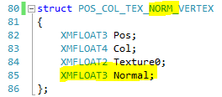

Next up is adding normal data to your vertices, here is some of the code using the original cube data:

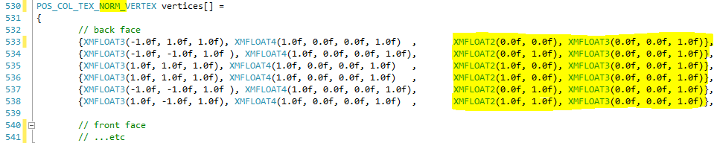
The above code adds normals to all the vertices representing the back face of the cube. Note how they all point in the same direction, i.e. down the positive z axis. This is because when the cube is in its untransformed model state it is essentially at (0, 0, 0) in the world, and not rotated, so the back face normal pointing down positive normal is correct for the rest state.

You might also think that using six normals just to define a single face is somewhat inefficient, and that is true in the case of a cube, but as models get more complex, and index buffers are introduced, you will see that this sharing of normals provides the necessary continuity of lighting across surfaces. You may also consider the idea of generating the normals to be time consuming, and difficult for complex objects. Again, this is true but the situation will be resolved like texture coordinates when you start loading model files that have had their normals created for them.

Again, as with the addition of texture coordinates, you now have a new type of vertex, so you need to change the stride to the new vertex size when you set the active vertex buffer:

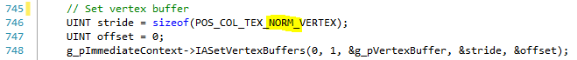

Now the input layout needs updating again to add the normals:

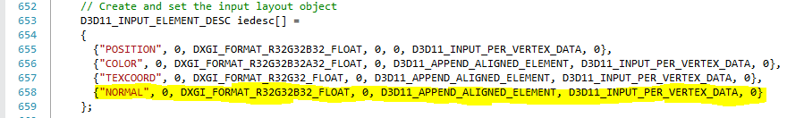

The new element highlighted tells Direct3D that it is a three element float (DXGI_FORMAT_R32G32B32_FLOAT) that is to be treated as a normal (NORMAL).

Finally you need to add a normal element to the vertex shader parameter list:

This tells the vertex shader to expect three additional floating point numbers that represent a normal, the NORMAL semantic matches that of the input element description above.

Adding Ambient and Directional Light

You first of all need to add a global direction vector and light colour, and a global ambient colour:

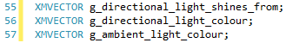

and set these values near the start of the RenderFrame() function:

g_directional_light_shines_from = XMVectorSet(0.0f, 0.0f, -1.0f, 0.0f);
g_directional_light_colour = XMVectorSet(0.0f, 1.0f, 0.0f, 0.0f);//green
g_ambient_light_colour = XMVectorSet(0.1f, 0.1f, 0.1f, 1.0f);//dark grey - always use a small value for ambient lighting

These values mean that the directional light is coming from the negative z direction, shining down the positive z axis, and is green in colour, and the ambient colour is a dark grey value. It's usually best to set the ambient to a dark colour as it will tend to hide other lighting if it is too bright. Notice the use of XMVectorSet() here. This is because XMVECTOR is highly optimised and to allow this you are forbidden to directly update the data.

Next you will need to update your constant buffer in order to upload the lighting data, here is an example:

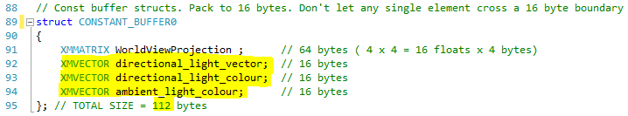

I've removed some of the parameters used from previous examples for clarity, please keep yours if you wish, but ensure the constant buffer is correctly formatted. Of course you will need to update the constant buffer description to tell it the correct number of bytes:

You will clearly need to update the constant structure in the vertex shader to accommodate the changes, here is the structure that reflects the above changes:

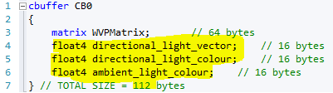

If you have your own additions to the constant buffer don't forget to take them into account when calculating the buffer size. Finally you need to update the constant buffer data and upload it every frame before each model is drawn (The highlighted value is discussed in the next section):

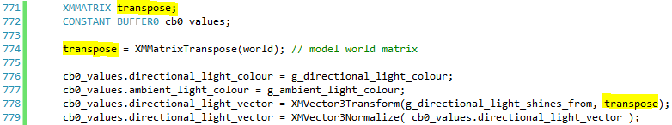

Moving the Light into Model Space

You have two choices when lighting objects. You can pass the light direction vector to the shader and calculate the lighting by rotating all the object normals by a matrix that represents the object's rotations in world space. This is a simple method that is often used, but it comes at the cost of additional work in the vertex shader as you have to rotate every normal. A slightly more complex but much more efficient method can be derived by imagining instead of rotating the normals into world space, instead rotate the light into model space. If done correctly the relative positions of the vectors will still be correct, and lighting can be done much more efficiently (compare one matrix rotation for a single light to hundreds or thousands for a models normals). This first diagram represents the rotation of all of the normals, in this case four rotations are required:
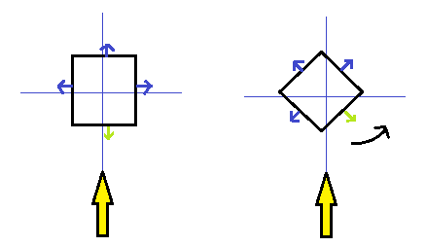

The next diagram shows that rotating instead of this you can rotate the light vector in the opposite direction to get the same relative positions, i.e. just a single rotation:

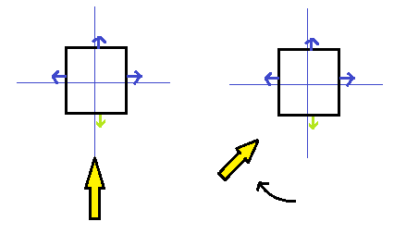

You could generate the correct rotation matrix for the light by concatenating all the negative rotational values used for the object world transformation in the reverse order. Of course it's not always straightforward to use these, so a better solution for directional lighting is to use XMMatrixTranspose(). Without going into the complex matrix maths involved, this function essentially returns a matrix that does the opposite rotational transformations of a given matrix in reverse order. So if you created a world matrix using a combination of rotations and translations and used it to transform a vertex into world space, the transpose of the world matrix would be a matrix that contains the reverse rotations that can be applied to a light direction vector in order to rotate it into the correct direction in model space.

In order to use this property of the transpose, for every object that you are drawing, immediately after creating the world matrix for an object you also create a transpose matrix and use it to transform the light vector into model space. This vector is then normalised as the transformation by the transpose may cause the vector to no longer be of unit length, then the constant buffer data is updated with the normalised vector.

Lighting Vertices in the Vertex Shader

The final step to get lighting working is to update the vertex shader to use the new lighting information, here is the full shader for the data used in this tutorial, you may need to update it if there is other data you wish to use from your own constant buffer and vertex shader setup:

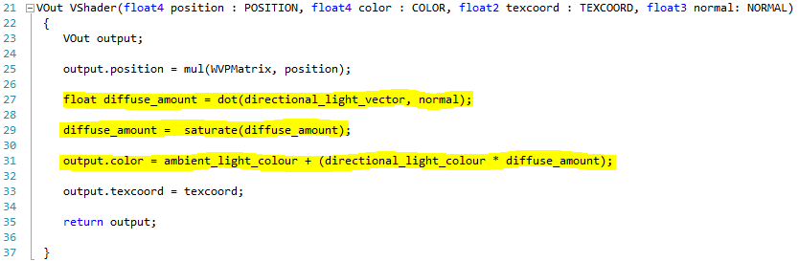

The diffuse_amount variable receives the dot product between the light vector and the normal, using the dot() intrinsic function, in order to determine the light intensity for a given vertex based on the angle between the two vectors. This value is then modified using the saturate() function, which restricts the values between 0.0 and 1.0. This is used as normals facing away from the light will generate a negative value for the dot product, and this could cause incorrect lighting on those faces that shouldn't be lit. The last step is to multiply the directional light colour by the amount of light to get the directional light amount, then add the ambient light to get the final color output which contains the lighting information to be used by the vertex shader.

Using the Lighting Colour in the Pixel Shader

You need to ensure that your pixel shader uses the lighting information contained in the color parameter, e.g.:

in this case the lighting colour and texture sample colour are multiplied together to get the final colour. If you want to just see the lighting you can just return the colour value.

Exercise 01 - Adding a Directional Light

- Create a new project based on your Tutorial 08 - Exercise 02 project (or one of the extra/advanced exercises), renaming it in the correct way.
- Use the tutorial above to add ambient and a directional light, updating the C++ and shader code as required. Choose your own colours, but it is best to keep the ambient values very low, 0.1f or less, and the and at least one element of the directional light colour quite high.
- You will need to update the vertices array to add normals. If you used the cube from a previous tutorial here are the normals for that cube in the correct order for each side (remember six vertices per side):
(0.0f, 0.0f, 1.0f) - for back faces (already done in tutorial code above)
(0.0f, 0.0f, -1.0f) - for front
(-1.0f, 0.0f, 0.0f) - for left
(1.0f, 0.0f, 0.0f) - for right
(0.0f, -1.0f, 0.0f) - for bottom
(0.0f, 1.0f, 0.0f) - for top

If you have used your own object, or significantly altered the cube, you will have to work out the normals for yourself.
- Check that the lighting works correctly for your object(s). Move around the object to ensure the faces away from the light direction are only lit by the ambient light.

Exercise 02

This exercise will look at adding code to manipulate the direction and colour of the directional light. As an extra part, a second will be added to the scene.

- Create a new project based on Tutorial 09 Exercise 01 called Tutorial 09 Exercise 02.
- Add code that allows you to rotate the directional light around the x, y and z axes, either using key presses or automatically. You could either:
  - Create a new rotational matrix as you would rotations for the world matrix, and then transform the light direction vector in the same way as the transpose code using XMVector3Transform() in the tutorial shows you how to rotate a vector.
  - Update the vector with values you provide, don't forget to normalise the vector if it is not of unit length. NOTE: Don't ever set an element of an XMVECTOR or XMMATRIX directly, always use the set or update functions, e.g. XMVectorSet(), XMVectorSetX(), etc.
- Add code to change the RGB colour using the keyboard. You don't necessarily need to limit the RGB colours between 0.0 and 1.0, you can use values outside for special effects. Greater than 1.0 might represent an extra strong light that saturates a scene, overriding detail in the textures. Less than 0.0 gives you a negative light, effectively sucking light out of the scene. Experiment with the values to see how this works.
- (EXTRA) Add a second directional light of a different colour that rotates constantly. Make sure you correctly update the constant buffer structures and size, and update the values in the same way as the first light each frame. You will also need to add the contribution of that light to each vertex in the vertex shader.
NOTE: At this stage you may get the following warning in the output window when you close the program:
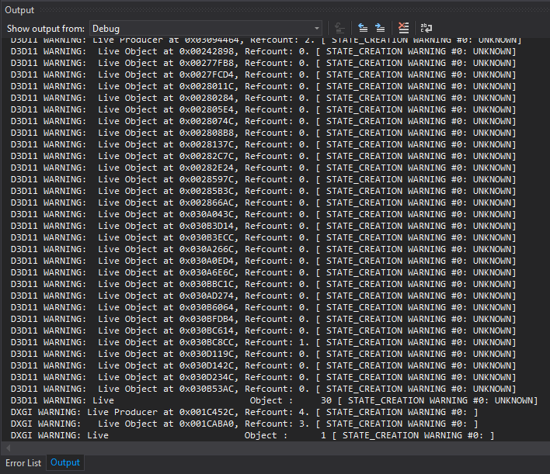
This is probably because you have missed something in ShutdownD3D(). Here is a correct list of items to delete and release if you have followed all the tutorials up until now:
void ShutdownD3D()
{

if (g_p2DText)
{
delete g_p2DText;
g_p2DText = nullptr;
}

if (g_pCamera)
{
delete g_pCamera;
g_pCamera = nullptr;
}

if (g_pVertexBuffer) g_pVertexBuffer->Release();
if (g_pInputLayout) g_pInputLayout->Release();
if (g_pConstantBuffer0) g_pConstantBuffer0->Release();
if (g_pVertexShader) g_pVertexShader->Release();
if (g_pPixelShader) g_pPixelShader->Release();
if (g_pBackBufferRTView) g_pBackBufferRTView->Release();
if (g_pZBuffer) g_pZBuffer->Release();
if (g_pTexture0) g_pTexture0->Release();
if (g_pSampler0) g_pSampler0->Release();
if (g_pSwapChain) g_pSwapChain->Release();
if (g_pImmediateContext) g_pImmediateContext->Release();
if (g_pD3DDevice) g_pD3DDevice->Release();

}
You should note here that some of the names you use may differ from what I have used

